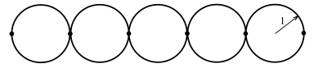

Let now consider the straight semi-infinite chain of rings with delta-coupling imposed at each vertex. Wave function components on j-th ring are as follows:

At the boundary points those components have following values

